SISTEM INFORMASI KERJA PRAKTIK (SIKP)

Business Requirements Document (BRD)

Yose Awanaustus Salawngi

05 2020

*Version 1.00*

# Document Revisions

|  |  |  |  |
| --- | --- | --- | --- |
| **Date** | **Version Number** | **Document Changes** | **Name** |
|  |  |  |  |
|  |  |  |  |
|  |  |  |  |
|  |  |  |  |
|  |  |  |  |
|  |  |  |  |
|  |  |  |  |
|  |  |  |  |
|  |  |  |  |
|  |  |  |  |

# Approvals

|  |  |  |  |  |
| --- | --- | --- | --- | --- |
| **Role** | **Name** | **Title** | **Signature** | **Date** |
| Front End | Julio |  |  | Senin, 15 Juni 2020 |
| Banck End | Dycha |  |  | Senin, 15 Juni 2020 |
| Documment Write | Yose |  |  | Senin, 15 Juni 2020 |
|  |  |  |  |  |
|  |  |  |  |  |
|  |  |  |  |  |

# Introduction

## Objectives

Dalam kegiatan SIKP mahasiswa yang telah melakukan pengajuan pra KP dan KP harus disetujui terlebih dahulu oleh koor. Maka, akan dibuatkan sistem yang dimana saat mahasiswa sudah melakukan pengajuan pra KP dan KP dapat dilihat oleh koor dan koor tersebut dapat verifikasi yaitu ditolak atau disetujui.

* Fitur ini hanya dapat dilakukan koor.
* Data pra KP dan KP diajukan oleh mahasiswa.
* Persetujuan dan penolakan hanya dapat dilakukan koor.

## Project Scope

Membuat sistem verifikasi untuk pra KP dan KP dimana diajukan oleh mahasiswa. Koor dapat melakukan penolakan atau persetujuan terhadap pengajuan tersebut.

### Functionality

* Melakukan penolakan atau persetujuan.

### Non Functionality

* Data dapat dilihat dan diakses dalam 24 jam dalam satu hari menggunakan komputer, laptop maupun smartphone.
* Dapat tidak di respon sama sekali.
* Dapat melakukan penolakan atau persetujuan terhadap pengajuan pra KP atau KP.

## System Perspective

### Assumptions

* Migrasi data sudah dilakukan dengan baik, tidak ada data yang hilang.
* Data ditampilkan sesuai.
* Data yang sudah disetujui atau ditolak dapat dilihat oleh mahasiswa.

### Constraints

* Tidak ada yang melakukan pengajuan pra KP atau KP.

### Risks

* Dosen koor tidak merespon sama sekali terhadap yang melakukan pengajuan.

### Issues

* Menunggu pengajuan pra KP atau KP dari mahasiswa.

# Business Process Overview

## Current Business Process (As-Is)

Pengajuan KP

%3CmxGraphModel%3E%3Croot%3E%3CmxCell%20id%3D%220%22%2F%3E%3CmxCell%20id%3D%221%22%20parent%3D%220%22%2F%3E%3CmxCell%20id%3D%222%22%20value%3D%22Dosen%20koor%22%20style%3D%22swimlane%3BstartSize%3D23%3B%22%20vertex%3D%221%22%20parent%3D%221%22%3E%3CmxGeometry%20x%3D%22290%22%20y%3D%2270%22%20width%3D%22200%22%20height%3D%22640%22%20as%3D%22geometry%22%2F%3E%3C%2FmxCell%3E%3CmxCell%20id%3D%223%22%20value%3D%22%22%20style%3D%22html%3D1%3Bshape%3Dmxgraph.sysml.actFinal%3BstrokeWidth%3D2%3BverticalLabelPosition%3Dbottom%3BverticalAlignment%3Dtop%3B%22%20vertex%3D%221%22%20parent%3D%222%22%3E%3CmxGeometry%20x%3D%2283%22%20y%3D%22580%22%20width%3D%2235%22%20height%3D%2235%22%20as%3D%22geometry%22%2F%3E%3C%2FmxCell%3E%3CmxCell%20id%3D%224%22%20style%3D%22edgeStyle%3DorthogonalEdgeStyle%3Brounded%3D0%3BorthogonalLoop%3D1%3BjettySize%3Dauto%3Bhtml%3D1%3BexitX%3D0.5%3BexitY%3D1%3BexitDx%3D0%3BexitDy%3D0%3BentryX%3D0.5%3BentryY%3D0%3BentryDx%3D0%3BentryDy%3D0%3B%22%20edge%3D%221%22%20parent%3D%222%22%20source%3D%225%22%20target%3D%226%22%3E%3CmxGeometry%20relative%3D%221%22%20as%3D%22geometry%22%2F%3E%3C%2FmxCell%3E%3CmxCell%20id%3D%225%22%20value%3D%22Klik%20Penjadwalan%20Ujian%22%20style%3D%22shape%3Drect%3Bhtml%3D1%3Brounded%3D1%3BwhiteSpace%3Dwrap%3Balign%3Dcenter%3B%22%20vertex%3D%221%22%20parent%3D%222%22%3E%3CmxGeometry%20x%3D%2218%22%20y%3D%22190%22%20width%3D%22164%22%20height%3D%2240%22%20as%3D%22geometry%22%2F%3E%3C%2FmxCell%3E%3CmxCell%20id%3D%226%22%20value%3D%22Dosen%20koor%20input%20jadwal%20Ujian%22%20style%3D%22shape%3Drect%3Bhtml%3D1%3Brounded%3D1%3BwhiteSpace%3Dwrap%3Balign%3Dcenter%3B%22%20vertex%3D%221%22%20parent%3D%222%22%3E%3CmxGeometry%20x%3D%2219%22%20y%3D%22280%22%20width%3D%22162%22%20height%3D%2240%22%20as%3D%22geometry%22%2F%3E%3C%2FmxCell%3E%3CmxCell%20id%3D%227%22%20value%3D%22DosenKoor%20membuka%20website%20SIKP%22%20style%3D%22shape%3Drect%3Bhtml%3D1%3Brounded%3D1%3BwhiteSpace%3Dwrap%3Balign%3Dcenter%3B%22%20vertex%3D%221%22%20parent%3D%222%22%3E%3CmxGeometry%20x%3D%2220%22%20y%3D%22130%22%20width%3D%22160%22%20height%3D%2230%22%20as%3D%22geometry%22%2F%3E%3C%2FmxCell%3E%3CmxCell%20id%3D%228%22%20style%3D%22edgeStyle%3DorthogonalEdgeStyle%3Brounded%3D0%3BorthogonalLoop%3D1%3BjettySize%3Dauto%3Bhtml%3D1%3BexitX%3D0.5%3BexitY%3D1%3BexitDx%3D0%3BexitDy%3D0%3BentryX%3D0.5%3BentryY%3D0%3BentryDx%3D0%3BentryDy%3D0%3BentryPerimeter%3D0%3BendArrow%3Dclassic%3BendFill%3D1%3B%22%20edge%3D%221%22%20parent%3D%222%22%20source%3D%229%22%20target%3D%223%22%3E%3CmxGeometry%20relative%3D%221%22%20as%3D%22geometry%22%2F%3E%3C%2FmxCell%3E%3CmxCell%20id%3D%229%22%20value%3D%22Kembali%20Ke%20halaman%20Utama%20SIKP%22%20style%3D%22shape%3Drect%3Bhtml%3D1%3Brounded%3D1%3BwhiteSpace%3Dwrap%3Balign%3Dcenter%3B%22%20vertex%3D%221%22%20parent%3D%222%22%3E%3CmxGeometry%20x%3D%2220.5%22%20y%3D%22515%22%20width%3D%22160%22%20height%3D%2230%22%20as%3D%22geometry%22%2F%3E%3C%2FmxCell%3E%3CmxCell%20id%3D%2210%22%20value%3D%22System%22%20style%3D%22swimlane%3BstartSize%3D23%3B%22%20vertex%3D%221%22%20parent%3D%221%22%3E%3CmxGeometry%20x%3D%22490%22%20y%3D%2270%22%20width%3D%22280%22%20height%3D%22640%22%20as%3D%22geometry%22%2F%3E%3C%2FmxCell%3E%3CmxCell%20id%3D%2211%22%20value%3D%22Menampilkan%20Halaman%20utama%20SIKP%22%20style%3D%22shape%3Drect%3Bhtml%3D1%3Brounded%3D1%3BwhiteSpace%3Dwrap%3Balign%3Dcenter%3B%22%20vertex%3D%221%22%20parent%3D%2210%22%3E%3CmxGeometry%20x%3D%2260%22%20y%3D%22130%22%20width%3D%22160%22%20height%3D%2230%22%20as%3D%22geometry%22%2F%3E%3C%2FmxCell%3E%3CmxCell%20id%3D%2212%22%20style%3D%22edgeStyle%3DorthogonalEdgeStyle%3Brounded%3D0%3BorthogonalLoop%3D1%3BjettySize%3Dauto%3Bhtml%3D1%3BexitX%3D0.5%3BexitY%3D1%3BexitDx%3D0%3BexitDy%3D0%3BentryX%3D0.5%3BentryY%3D0%3BentryDx%3D0%3BentryDy%3D0%3B%22%20edge%3D%221%22%20parent%3D%2210%22%20source%3D%2213%22%20target%3D%2214%22%3E%3CmxGeometry%20relative%3D%221%22%20as%3D%22geometry%22%2F%3E%3C%2FmxCell%3E%3CmxCell%20id%3D%2213%22%20value%3D%22%22%20style%3D%22rhombus%3BwhiteSpace%3Dwrap%3Bhtml%3D1%3B%22%20vertex%3D%221%22%20parent%3D%2210%22%3E%3CmxGeometry%20x%3D%22125%22%20y%3D%22390%22%20width%3D%2230%22%20height%3D%2230%22%20as%3D%22geometry%22%2F%3E%3C%2FmxCell%3E%3CmxCell%20id%3D%2214%22%20value%3D%22Menampilkan%20Jadwal%20Ujian%20beserta%20ruang%20ujian.%22%20style%3D%22shape%3Drect%3Bhtml%3D1%3Brounded%3D1%3BwhiteSpace%3Dwrap%3Balign%3Dcenter%3B%22%20vertex%3D%221%22%20parent%3D%2210%22%3E%3CmxGeometry%20x%3D%2260%22%20y%3D%22515%22%20width%3D%22160%22%20height%3D%2230%22%20as%3D%22geometry%22%2F%3E%3C%2FmxCell%3E%3CmxCell%20id%3D%2215%22%20style%3D%22edgeStyle%3DorthogonalEdgeStyle%3Brounded%3D0%3BorthogonalLoop%3D1%3BjettySize%3Dauto%3Bhtml%3D1%3BexitX%3D1%3BexitY%3D0.5%3BexitDx%3D0%3BexitDy%3D0%3BentryX%3D0%3BentryY%3D0.5%3BentryDx%3D0%3BentryDy%3D0%3B%22%20edge%3D%221%22%20source%3D%227%22%20target%3D%2211%22%20parent%3D%221%22%3E%3CmxGeometry%20relative%3D%221%22%20as%3D%22geometry%22%2F%3E%3C%2FmxCell%3E%3CmxCell%20id%3D%2216%22%20style%3D%22edgeStyle%3DorthogonalEdgeStyle%3Brounded%3D0%3BorthogonalLoop%3D1%3BjettySize%3Dauto%3Bhtml%3D1%3BexitX%3D0.5%3BexitY%3D1%3BexitDx%3D0%3BexitDy%3D0%3BentryX%3D1%3BentryY%3D0.5%3BentryDx%3D0%3BentryDy%3D0%3B%22%20edge%3D%221%22%20source%3D%2211%22%20target%3D%225%22%20parent%3D%221%22%3E%3CmxGeometry%20relative%3D%221%22%20as%3D%22geometry%22%2F%3E%3C%2FmxCell%3E%3CmxCell%20id%3D%2217%22%20value%3D%22Pembimbing%22%20style%3D%22swimlane%3BstartSize%3D23%3B%22%20vertex%3D%221%22%20parent%3D%221%22%3E%3CmxGeometry%20x%3D%2290%22%20y%3D%2270%22%20width%3D%22200%22%20height%3D%22640%22%20as%3D%22geometry%22%2F%3E%3C%2FmxCell%3E%3CmxCell%20id%3D%2218%22%20value%3D%22Pembimbing%20menyerahkan%20data%20mahasiswa%20yang%20telah%20disetujui%22%20style%3D%22shape%3Drect%3Bhtml%3D1%3Brounded%3D1%3BwhiteSpace%3Dwrap%3Balign%3Dcenter%3B%22%20vertex%3D%221%22%20parent%3D%2217%22%3E%3CmxGeometry%20x%3D%2220%22%20y%3D%22120%22%20width%3D%22160%22%20height%3D%2250%22%20as%3D%22geometry%22%2F%3E%3C%2FmxCell%3E%3CmxCell%20id%3D%2219%22%20value%3D%22%22%20style%3D%22shape%3Dellipse%3Bhtml%3D1%3BfillColor%3D%23000000%3BstrokeWidth%3D2%3BverticalLabelPosition%3Dbottom%3BverticalAlignment%3Dtop%3Bperimeter%3DellipsePerimeter%3B%22%20vertex%3D%221%22%20parent%3D%2217%22%3E%3CmxGeometry%20x%3D%2281%22%20y%3D%2260%22%20width%3D%2230%22%20height%3D%2230%22%20as%3D%22geometry%22%2F%3E%3C%2FmxCell%3E%3CmxCell%20id%3D%2220%22%20value%3D%22%22%20style%3D%22endArrow%3Dclassic%3Bhtml%3D1%3BexitX%3D0.5%3BexitY%3D1%3BexitDx%3D0%3BexitDy%3D0%3B%22%20edge%3D%221%22%20parent%3D%2217%22%20source%3D%2219%22%3E%3CmxGeometry%20width%3D%2250%22%20height%3D%2250%22%20relative%3D%221%22%20as%3D%22geometry%22%3E%3CmxPoint%20x%3D%22262%22%20y%3D%22300%22%20as%3D%22sourcePoint%22%2F%3E%3CmxPoint%20x%3D%2296%22%20y%3D%22120%22%20as%3D%22targetPoint%22%2F%3E%3C%2FmxGeometry%3E%3C%2FmxCell%3E%3CmxCell%20id%3D%2221%22%20style%3D%22edgeStyle%3DorthogonalEdgeStyle%3Brounded%3D0%3BorthogonalLoop%3D1%3BjettySize%3Dauto%3Bhtml%3D1%3BexitX%3D0%3BexitY%3D0.5%3BexitDx%3D0%3BexitDy%3D0%3BentryX%3D0.5%3BentryY%3D1%3BentryDx%3D0%3BentryDy%3D0%3B%22%20edge%3D%221%22%20source%3D%2213%22%20target%3D%226%22%20parent%3D%221%22%3E%3CmxGeometry%20relative%3D%221%22%20as%3D%22geometry%22%2F%3E%3C%2FmxCell%3E%3CmxCell%20id%3D%2222%22%20value%3D%22Input%20berhasil%22%20style%3D%22edgeLabel%3Bhtml%3D1%3Balign%3Dcenter%3BverticalAlign%3Dmiddle%3Bresizable%3D0%3Bpoints%3D%5B%5D%3B%22%20vertex%3D%221%22%20connectable%3D%220%22%20parent%3D%2221%22%3E%3CmxGeometry%20x%3D%22-0.6133%22%20y%3D%222%22%20relative%3D%221%22%20as%3D%22geometry%22%3E%3CmxPoint%20x%3D%2279%22%20y%3D%2243%22%20as%3D%22offset%22%2F%3E%3C%2FmxGeometry%3E%3C%2FmxCell%3E%3CmxCell%20id%3D%2223%22%20value%3D%22Input%20gagal%22%20style%3D%22edgeLabel%3Bhtml%3D1%3Balign%3Dcenter%3BverticalAlign%3Dmiddle%3Bresizable%3D0%3Bpoints%3D%5B%5D%3B%22%20vertex%3D%221%22%20connectable%3D%220%22%20parent%3D%2221%22%3E%3CmxGeometry%20x%3D%22-0.4928%22%20y%3D%222%22%20relative%3D%221%22%20as%3D%22geometry%22%3E%3CmxPoint%20as%3D%22offset%22%2F%3E%3C%2FmxGeometry%3E%3C%2FmxCell%3E%3CmxCell%20id%3D%2224%22%20style%3D%22edgeStyle%3DorthogonalEdgeStyle%3Brounded%3D0%3BorthogonalLoop%3D1%3BjettySize%3Dauto%3Bhtml%3D1%3BexitX%3D0%3BexitY%3D0.5%3BexitDx%3D0%3BexitDy%3D0%3BentryX%3D1%3BentryY%3D0.5%3BentryDx%3D0%3BentryDy%3D0%3B%22%20edge%3D%221%22%20source%3D%2214%22%20target%3D%229%22%20parent%3D%221%22%3E%3CmxGeometry%20relative%3D%221%22%20as%3D%22geometry%22%2F%3E%3C%2FmxCell%3E%3CmxCell%20id%3D%2225%22%20style%3D%22edgeStyle%3DorthogonalEdgeStyle%3Brounded%3D0%3BorthogonalLoop%3D1%3BjettySize%3Dauto%3Bhtml%3D1%3BexitX%3D1%3BexitY%3D0.5%3BexitDx%3D0%3BexitDy%3D0%3BentryX%3D0.5%3BentryY%3D0%3BentryDx%3D0%3BentryDy%3D0%3B%22%20edge%3D%221%22%20source%3D%226%22%20target%3D%2213%22%20parent%3D%221%22%3E%3CmxGeometry%20relative%3D%221%22%20as%3D%22geometry%22%2F%3E%3C%2FmxCell%3E%3CmxCell%20id%3D%2226%22%20style%3D%22edgeStyle%3DorthogonalEdgeStyle%3Brounded%3D0%3BorthogonalLoop%3D1%3BjettySize%3Dauto%3Bhtml%3D1%3BexitX%3D1%3BexitY%3D0.5%3BexitDx%3D0%3BexitDy%3D0%3B%22%20edge%3D%221%22%20source%3D%2218%22%20target%3D%227%22%20parent%3D%221%22%3E%3CmxGeometry%20relative%3D%221%22%20as%3D%22geometry%22%2F%3E%3C%2FmxCell%3E%3C%2Froot%3E%3C%2FmxGraphModel%3E

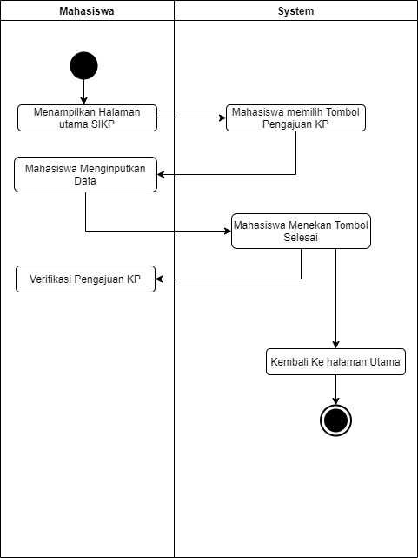

Pengajuan Pra KP

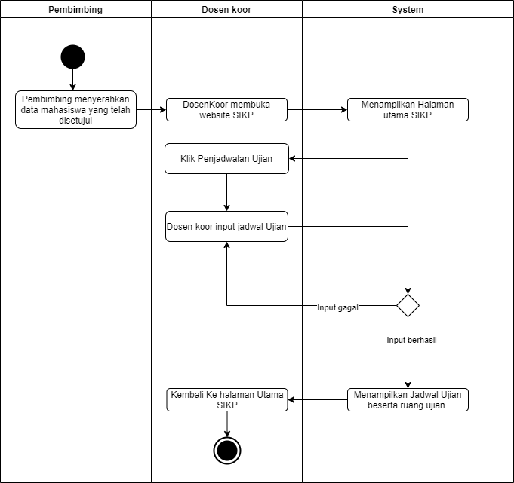

## Proposed Business Process (To-Be)

* Koor menunggu pengajuan pra KP dan KP dari mahasiswa.
* Koor melakukan verifikasi tolak atau setuju.

# User and System Requirements

The requirements in this document are prioritized as follows:

|  |  |  |
| --- | --- | --- |
| **Value** | **Rating** | **Description** |
| 1 | Critical | This requirement is critical to the success of the project. The project will not be possible without this requirement. |
| 2 | High | This requirement is high priority, but the project can be implemented at a bare minimum without this requirement. |
| 3 | Medium | This requirement is somewhat important, as it provides some value but the project can proceed without it. |
| 4 | Low | This is a low priority requirement, or a “nice to have” feature, if time and cost allow it. |
| 5 | Future | This requirement is out of scope for this project, and has been included here for a possible future release. |

## Functional Requirements

|  |  |  |  |  |  |
| --- | --- | --- | --- | --- | --- |
| **Req#** | **Priority** | **Description** | **Rationale** | **Use Case Reference** | **Impacted Stakeholders** |
| **General/Base Functionality** | | | | | |
| VKP-A001 | 1 | Aktor melakukan verifikasi tolak atau setuju untuk pra KP atau KP | Koor menunggu pengajuan pra KP atau KP dari mahasiswa lalu koor melakukan verifikasi tolak atau setuju terhadap pengajuan |  | Koor, Mahasiswa |
|  |  |  |  |  |  |
|  |  |  |  |  |  |
|  |  |  |  |  |  |
|  |  |  |  |  |  |
| **Usability Requirment** | | | | | |
| VKP-B001 | 1 | Menampilkan antarmuka grafis yang dimana terdapat tabel. Tabel tersebut digunakan untuk menampilkan data dari pengajuan Pra KP dan KP serta terdapat tombol untuk persetujuan atau tolak. |  |  |  |
|  |  |  |  |  |  |
|  |  |  |  |  |  |
|  |  |  |  |  |  |
|  |  |  |  |  |  |
|  | | | | | |
|  |  |  |  |  |  |
|  |  |  |  |  |  |
|  |  |  |  |  |  |
|  |  |  |  |  |  |
|  |  |  |  |  |  |
|  | | | | | |
|  |  |  |  |  |  |
|  |  |  |  |  |  |
|  |  |  |  |  |  |
|  |  |  |  |  |  |
|  |  |  |  |  |  |
|  | | | | | |
|  |  |  |  |  |  |
|  |  |  |  |  |  |
|  |  |  |  |  |  |
|  |  |  |  |  |  |
|  |  |  |  |  |  |
|  | | | | | |
|  |  |  |  |  |  |
|  |  |  |  |  |  |
|  |  |  |  |  |  |
|  |  |  |  |  |  |
|  |  |  |  |  |  |

## Non-Functional Requirements

|  |  |
| --- | --- |
| **ID** | **Requirement** |
| VKP-C001 | Pengajuan pra KP. |
| VKP-C002 | Pengajuan KP. |
|  |  |
| VKP-C003 | Koor melakukan penolakan atau persetujuan. |
|  |  |
|  |  |
|  |  |

# Appendices

## List of Acronyms

## Glossary of Terms

## Related Documents